

**CD2L**

**AUTOMATED ATTENDANCE SYSTEM**

**HARISH S – 3rd Yr –B.TECH AI & DS**

**SHANMATHI L A – 3rd Yr –B.TECH AI & DS**

**SWETHA S – 3rd Yr –B.E CSE**



# NOV 2023

* **OVERVIEW OF THE PROJECT :**
* This project aims to create a facial atendance system using webcam to detect and recognize faces in real time. It records the attendance of

recognizes individuals and store the data in CSV files

* **REQUIRMENTS:**
* Open CV- Open computer vision used for basic image and video manuplation such as reading,writing and displaying images and video streams.

* face_recognition - It provides a high level, easy to use interface for face detection and facial face recognition.

* numpy – Numerical python provides support for large,multi dimensional arrays,matrices.

* Pickle – It is a python module to serialize and deserialize the objects.

* datetime – It provides a classes for working with dates and times.

**1.MAIN COMPONENTS :**

* **ENCODING NEW FACES**

The scripts starts by loading a directory of formal pictures from a specified path and it resizes the images and encodes the faces in each image using face_recognition library.

**2.REAL TIME WEBCAM CAPTURE:**

* The script captures video from the webcam using OPEN-CV and it sets the dimensions of the video frame to pixels

**3. RECOGNIZING AND MARKING ATTENDANCE:**

* The scripts compares the faces detected in webcam feed with the known faces encoding and a recognized face is detected, it marks the attendance according to the date and in-time.

**4.OUTPUT CSV FILE :**

* Attendance data is stored in CSV file named ‘ATTENDANCE .CSV’ • The CSV file has a columns Names,Date,In-time and Out-time.

**5.ATTENDANCE SESSION DURATION :**

* If a face is recognized for more than 5 seconds,it is consider as attendance is being taken

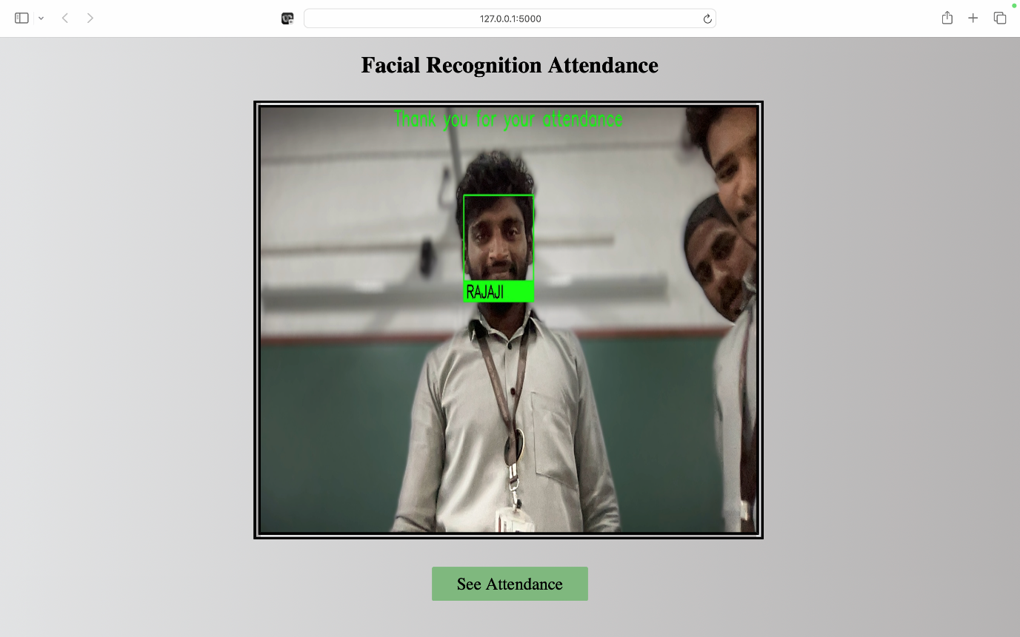

6. **ROUTES:**

The flask application defines several routes.

* "/" - The home page that provides links to other pages.
* "/attendance" - Displays the attendance data.
* "/video" - Provides a real-time video feed.
* "/upload" - Allows users to upload additional known faces.
* "/download" - Allows users to download the attendance data as a CSV files

**7.Read and Update CSV:**

* The application can read attendance data from a CSV file and update it as needed.

**8.File Upload:**

* Users can upload additional unknown faces to add new users

**9.File Download:**

* Only admins can download the attendance data as a CSV file.

**10. Running the Application:**

* The application runs with the app.run command, serving on "0.0.0.0" and in debug mode.

**Conclusion:**

* Thus, the model provided a python script based on attendance system that uses OPENCV and face_recognition library to recognize indivuals and record their attendance.